SEAH Focal Point Flow
Chatbot | Comments
 | Make more prominent, such as putting the icon right below the box instead of bottom right.
 | Update button text.  Report sexual exploitation, sexual abuse, and sexual harassment
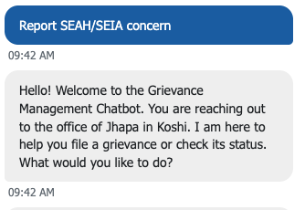 | Remove the hello text – redundant with opening welcome message.
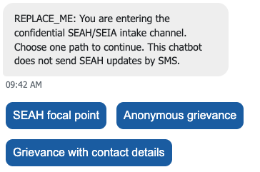 | Update text.  You are reporting a sexual exploitation, sexual abuse, or sexual harassment concern. All information you will provide will be treated with confidentiality.
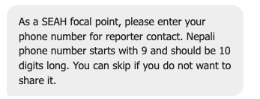 | Update text.  As a SEAH focal point, please enter your phone number. Nepali phone number starts with 9 and should be 10 digits long.  [User should not be able to skip.]
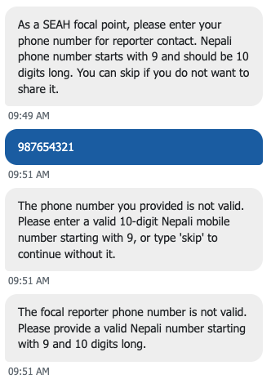 | Double error prompt. Please fix.
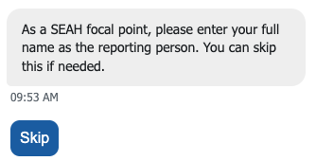 | Name should be asked before phone number.  Update text.  As a SEAH focal point, please enter your full name.  [User should not be able to skip.]
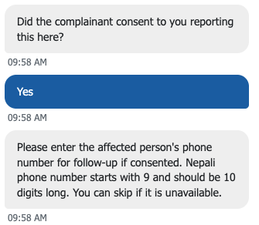 | The team has decided to have the question naming the complainant removed given the risks associated with getting consent. Please remove the question on complainant consent.
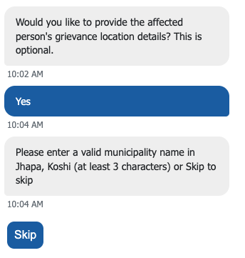 | Update text and combine two buttons.  If you know the location where the incident happened, please enter a valid municipality name. Skip if not.
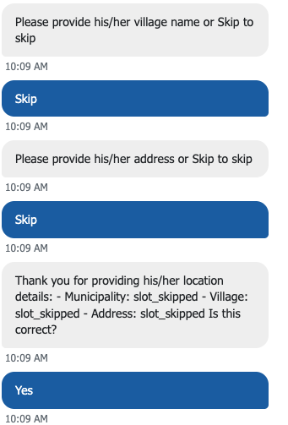 | Remove all these.
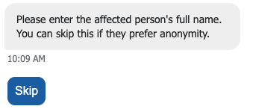 | The team has decided to have the question naming the complainant removed given the risks associated with getting consent.
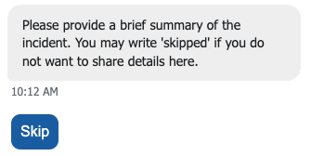 | Should not be able to skip this question.  Please provide a brief summary of the SEAH incident.
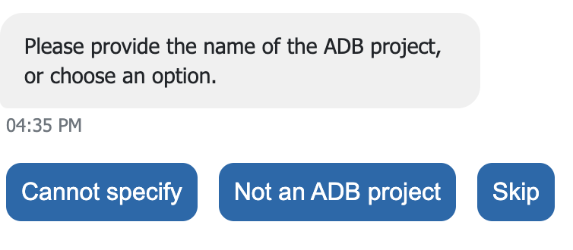 | Please replace question with:  Is the alleged perpetrator employed by an ADB project?  Yes  No
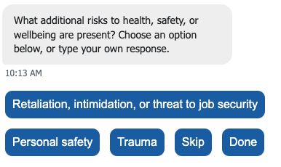 | Done should be None.  Remove Skip.
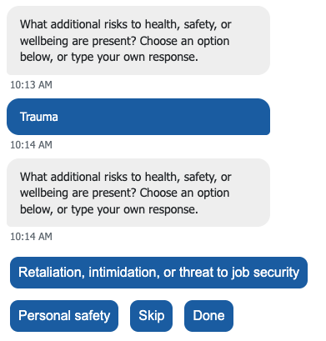 | Instead of asking the same question, is it possible for user to choose more than 1 answer (i.e., click more than 1 button)?
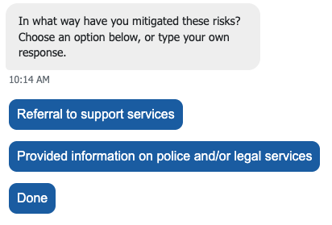 | Done should be None
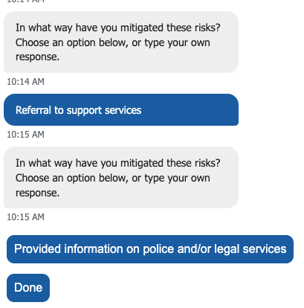 | Instead of asking the same question, is it possible for user to choose more than 1 answer (i.e., click more than 1 button)?
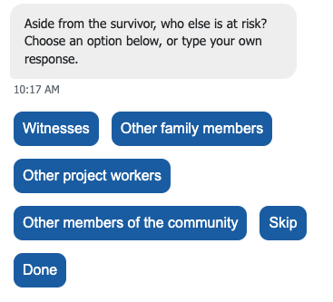 | Done should be None.  Remove Skip.
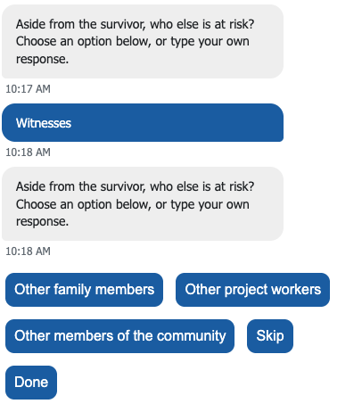 | Instead of asking the same question, is it possible for user to choose more than 1 answer (i.e., click more than 1 button)?
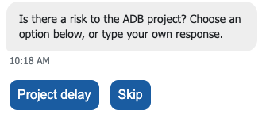 | Add None button.  Remove Skip.
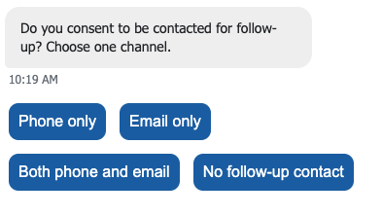 | Update text.  Does the complainant agree to be contacted for follow-up?
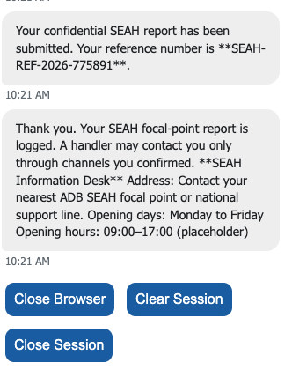 | Update acknowledgment text.  Thank you for reporting this incident. This confidential SEAH report has been submitted. Your reference number is XXX  Please make sure to refer the complainant to proper support. Here are the possible support services: [list to be provided]
 | Only one final button needed: End session

SEAH Complainant (Anonymous Victim-Survivor) Flow
Chatbot | Comments
 | Remove the hello text – redundant with opening welcome message.
 | Update text.  You are reporting a sexual exploitation, sexual abuse, or sexual harassment concern. All information you will provide will be treated with confidentiality.
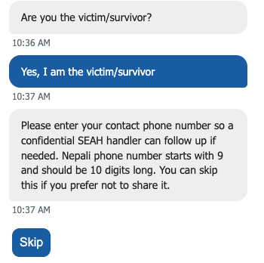 | Update text.  Please enter your phone number so we can contact you for any needed follow-up. You may skip if you do not want to share it.
Add email address question.

Please enter your email address so we can contact you for any needed follow-up. Skip if you do not want to share it.

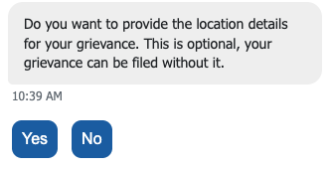 | Update text.  To provide the location where the incident happened, please enter a valid municipality name. You may Skip if you do not want to share or you do not know the location.
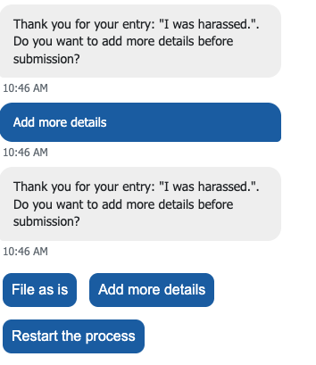 | If user clicks Add more details, update text.  Please enter additional details.
Please insert missing question on consent for follow-up before acknowledgement.

Do you agree to being contacted for follow-up?

Phone only
Email only
Phone and email
No
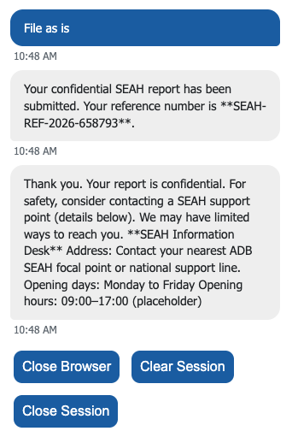 | Thank you for reporting this incident. This confidential SEAH report has been submitted. Your reference number is XXX  Here are the support services that may help victim-survivors: [list to be provided]

SEAH Complainant (Identified Victim-Survivor) Flow
Chatbot | Comments
 | Align text updates with the preceding table comments.
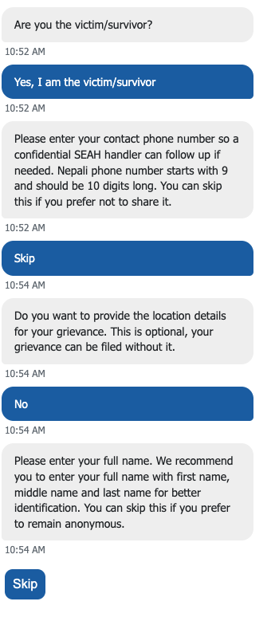 | Name should be asked before contact number.  Please enter your full name. We recommend you to enter your first name, middle name and last name for better identification. You may Skip if you want to be anonymous.
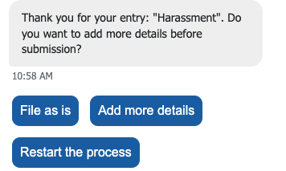 | Replace Restart the process with Rewrite the summary

SEAH Complainant (Not the Victim-Survivor) Flow
Chatbot | Comments
 | Align text updates with the preceding table comments.
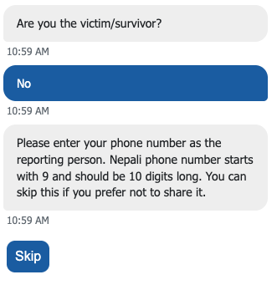 | Consent should be asked after user says No.  Did the victim-survivor agree that you file this complaint?  Yes  No  If user clicks No, add follow-up question:  Is there an immediate danger to the life of the victim-survivor?  If user clicks No, proceed with this final acknowledgement message.  Thank you. Here are the potential support services that can help the victim-survivor: [list to be provided].
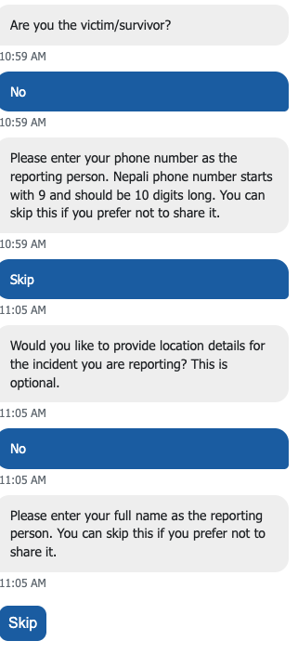 | Name should be asked before phone number.  Please provide your full name. You may skip if you want to be anonymous.

